Project Design Phase-II

Data Flow Diagram

|  |  |
| --- | --- |
| **Date** | 27October 2022 |
| **Team ID** | PNT2022TMID23730 |
| **Project Name** | Real -Time Communication System PoweredBy  AI For Specially Abled |
| **Maximum Marks** | 4 Marks |

# Data Flow Diagrams:

A Data Flow Diagram (DFD) is a traditional visual representation of the information flows within a system. A neat and clear DFD can depict the right amount of the system requirement graphically. It shows how data enters and leaves the system, what changes the information, and where data is stored.

# Example: (Simplified)

Example: DFD Level 0 (Industry Standard)

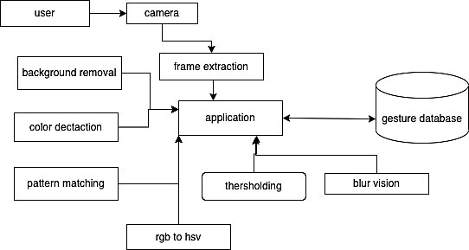

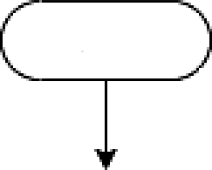

start

device initialization

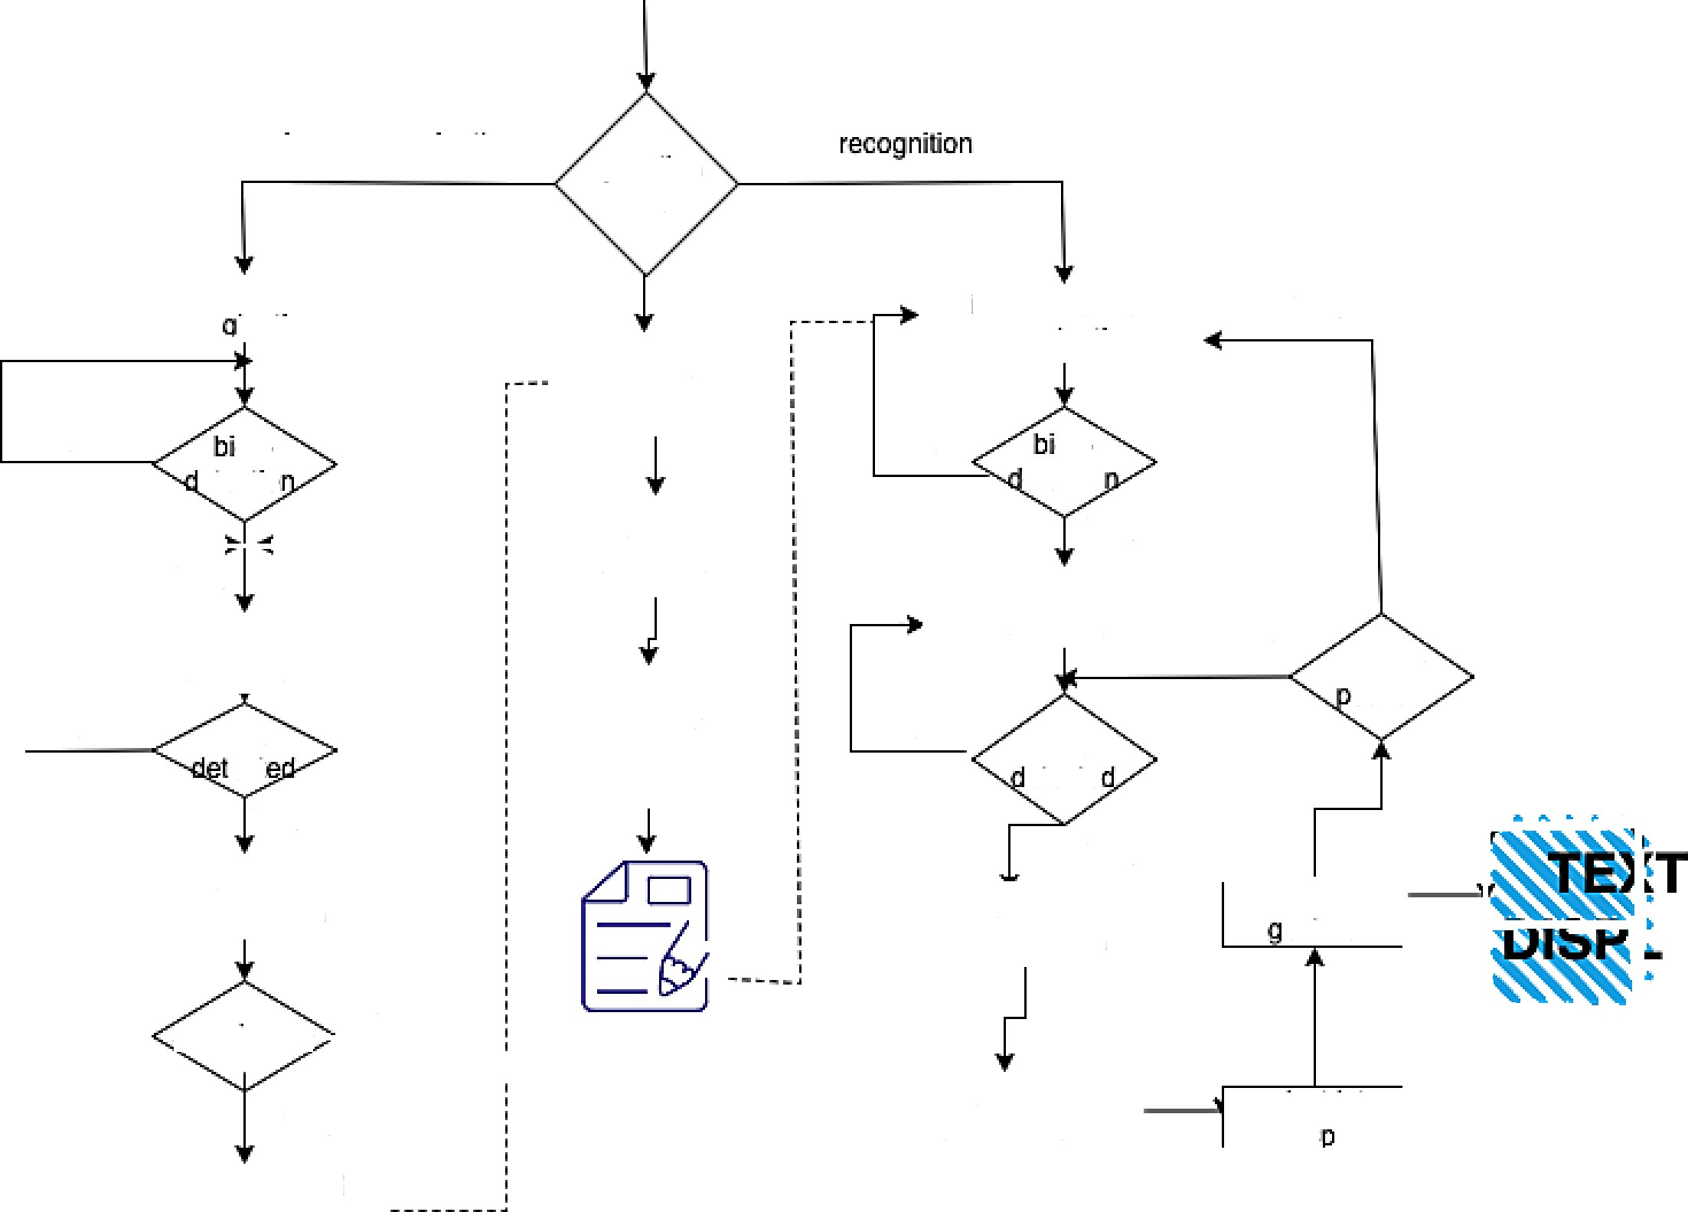

image recogination

operation mode?

YES

NO

gg

etectio

NO

g g etectio

YES

YES

NO

change

ostion

NO

hand

*e*ct

YES

NO

hand et*e*ct*e*

YES

classify hand esure

AY

NO

save image

; sign database . xml

YES

projem into FLD s ace

do hand normalization

do hand segmentation

save segmented image for training

calculate FLD space

hand region esimation

do hand segmentation

hand region esimation

do hand normaliztion

Initialization for training

initialzation for

recogination

initialzation for image

reco ination

**User Stories**

Use the below template to list all the user stories for the product.

|  |  |  |  |  |  |  |
| --- | --- | --- | --- | --- | --- | --- |
| **User Type** | **Functional Requirement (Epic)** | **User Story Number** | **User Story / Task** | **Acceptance criteria** | **Priority** | **Release** |
| ***Customer***  *(Desktop user)* | Registration | USN-1 | **Not Required** | The user may access my dashboard or account. | High | Sprint-1 |
|  | **Login** | USN-2 | **Not Required** |  | High | Sprint-1 |
|  | **Dashboard** | USN-3 | **Not Required** |  |  |  |
| ***Customer***  *(Desktop user)* | **Main page** | USN-4 | Once user click, user can enter the website as a user and get the instructions for using the  software. | After clicking, the user may access the website. | Medium | Sprint-1 |
| *Customer (Desktop user)* | **Guidelines** | USN-5 | The user can read the instructions to learn how the application works. | The user can review the instructions. | Medium | Sprint-1 |
| ***Customer*** *(Desktop user)* | **Convert Sign** | USN-6 | A user can access the Main screen by clicking the  Convert sign button. | When a user clicks the Convert button, I am sent to  the main screen**.** | Medium | Sprint-2 |
| ***Customer*** *(Desktop user)* | **Camera(Hand movement detection)** | USN-7 | A user can enter text by waving my hand gestures in front of the camera. | My hand signal may be correctly displayed to the  camera by the user. | High | Sprint-2 |
| ***Customer*** *(Desktop user)* | **Voice mode** | USN-8 | Once the text has been received, the user can  select the voice option to hear the text spoken. | The voice mode, which presents  the text as speech, can be selected by the user. | High | Sprint-2 |
| ***Customer Care Executive*** | **Provide the necessary functionalities required to use the app.** |  | Users may submit the necessary camera specifications and other details as executives, ensuring the software runs well. | The necessary camera specifications and other information can be provided by  the user. | Low | Sprint-1 |
| ***Customer Care Executive*** | **Check the performance of the app** |  | A user can review the use and enquiries received from end users in their capacity as an executive. | The use and questions received  from the end users are viewable by the user. | Medium | Sprint-1 |

|  |  |  |  |  |  |  |
| --- | --- | --- | --- | --- | --- | --- |
| ***Administrator*** | **Receive queries based on the usage** |  | In order to help the users of the app utilise it  successfully, an administrator may take the questions from the customer service and repeat the testing step while loading the other indicators in the dataset. | The user can ask the customer service representative questions and repeat the necessary steps. | High | Sprint-2 |